2.4 Navigation and Pagination

This section will guide you to:

* Add navigation using a nav-bar in Bootstrap
* Use pagination to navigate in Bootstrap

This guide has five subsections, namely:

2.4.1 Building a navbar using Bootstrap in your code editor

2.4.2 Viewing the results in browser

2.4.3 Adding pagination to your website using Bootstrap

2.4.4 Viewing the results in browser

2.4.5 Pushing the code to Github repositories

**Step 2.4.1:** Building a navbar using Bootstrap in your code editor

* Open Visual Studio Code.
* Right clickon the **File menu** of the code editor -> Select *New File.*
* Enter the below code resolving the warning and errors due to compatibility-related issues.
* Right clickon the **File menu** of the code editor -> Select *Save as* -> Enter the filename (nav.html) -> Click *Save.*

**<!DOCTYPE html>**

**<html>**

**<head>**

**<meta name="viewport" content="width=device-width, initial-scale=1">**

**<link rel="stylesheet" href="https://stackpath.bootstrapcdn.com/bootstrap/4.1.3/css/bootstrap.min.css" integrity="sha384-MCw98/SFnGE8fJT3GXwEOngsV7Zt27NXFoaoApmYm81iuXoPkFOJwJ8ERdknLPMO" crossorigin="anonymous">**

**<script src="https://ajax.googleapis.com/ajax/libs/jquery/3.2.1/jquery.min.js"></script>**

**<script src="https://maxcdn.bootstrapcdn.com/bootstrap/3.3.7/js/bootstrap.min.js"></script>**

**</head>**

**<body>**

**<nav class="navbar navbar-expand-md">**

**<a class="navbar-brand" href="#"><img src="images/noodle.png" alt=""></a>**

**<button class="navbar-toggler navbar-dark" type="button" data-toggle="collapse" data-target="#main-navigation">**

**<span class="navbar-toggler-icon"></span>**

**</button>**

**<div class="collapse navbar-collapse" id="main-navigation">**

**<ul class="navbar-nav">**

**<li class="nav-item">**

**<a class="nav-link" href="index.html">Home</a>**

**</li>**

**<li class="nav-item">**

**<a class="nav-link" href="form.html">Contact</a>**

**</li>**

**<li class="nav-item">**

**<a class="nav-link" href="page.html">Pagination</a>**

**</li>**

**</ul>**

**</div>**

**</nav>**

**<p>The 'nav' tag is used to define a block of links for navigation, for the current page, or for other pages.</p>**

**</body>**

**</html>**

**Step 2.4.2:** Viewing the results in your local browser

* Navigate to the directory where nav.html is stored using the File Explorer.
* Double-click the nav.html file to open it in your default browser.

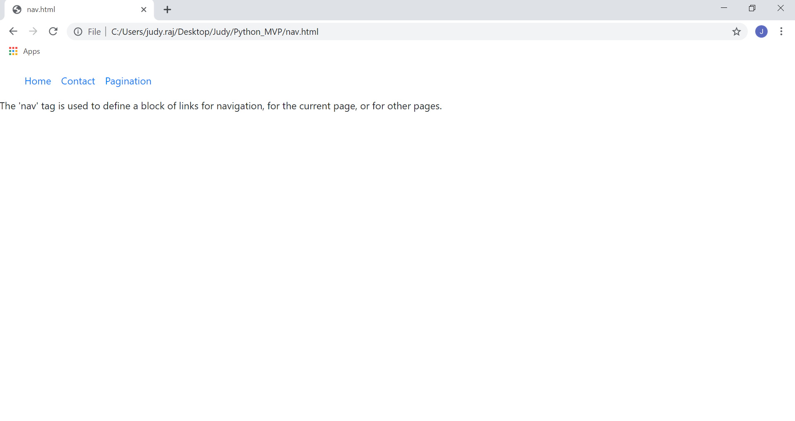

**Step 2.4.3:** Adding pagination to your website using Bootstrap

Open your code editor and create a new file to type the code in.

* Right clickon the **File menu** of the code editor -> Select *New File.*
* Enter the below code resolving the warning and errors due to compatibility-related issues.
* Right clickon the **File menu** of the code editor -> Select *Save as* -> Enter the filename (page.html) -> Click *Save.*

**<!DOCTYPE html>**

**<html>**

**<head>**

**<meta name="viewport" content="width=device-width, initial-scale=1">**

**<link rel="stylesheet" href="https://stackpath.bootstrapcdn.com/bootstrap/4.1.3/css/bootstrap.min.css" integrity="sha384-MCw98/SFnGE8fJT3GXwEOngsV7Zt27NXFoaoApmYm81iuXoPkFOJwJ8ERdknLPMO" crossorigin="anonymous">**

**<script src="https://ajax.googleapis.com/ajax/libs/jquery/3.2.1/jquery.min.js"></script>**

**<script src="https://maxcdn.bootstrapcdn.com/bootstrap/3.3.7/js/bootstrap.min.js"></script>**

**</head>**

**<body>**

**<p>Pagination is used to divide a document into different pages with numbers.</p>**

**<nav aria-label="Pagination Demo">**

**<ul class="pagination">**

**<li class="page-item"><a class="page-link" href="#">Previous</a></li>**

**<li class="page-item"><a class="page-link" href="index.html">1</a></li>**

**<li class="page-item"><a class="page-link" href="form.html">2</a></li>**

**<li class="page-item"><a class="page-link" href="nav.html">3</a></li>**

**<li class="page-item"><a class="page-link" href="#">Next</a></li>**

**</ul>**

**</nav>**

**</body>**

**</html>**

**Step 2.4.4:** Viewing the results in your local browser

* Navigate to the directory where page.html is stored using the File Explorer.
* Double-click the page.html file to open it in your default browser.

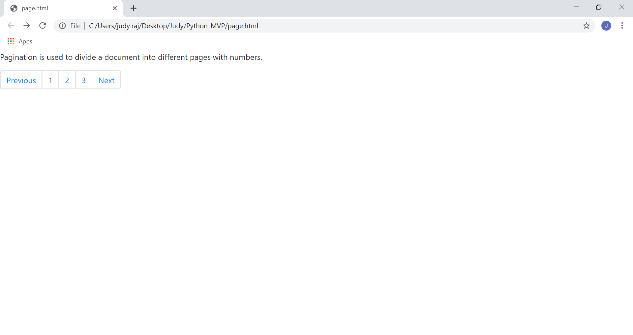

**Step 2.4.5:** Pushing the code to your GitHub repositories

Open your command prompt and navigate to the folder where you have created your files

cd <folder path>

Initialize your repository using the following command:

git init

Add all the files to your git repository using the following command:

git add .

Commit the changes using the following command:

git commit . -m “Changes have been committed.”

Push the files to the folder you initially created using the following command:

git push -u origin master